Cloud Architect, Data Analyst

Analytics

**Lab Steps**

Task 1: Sign in to AWS Management Console

1. Click on the  button, and you will get redirected to AWS Console in a new browser tab.
2. On the AWS sign-in page,

* Leave the Account ID as default. Never edit/remove the 12 digit Account ID present in the AWS Console. otherwise, you cannot proceed with the lab.
* Now copy your **User Name** and **Password** in the Lab Console to the **IAM Username and Password** in AWS Console and click on the **Sign in** button

     3. Once Signed In to the AWS Management Console, Make the default AWS Region as **US East (N. Virginia) us-east-1.**

Task 2: Setup workgroup

1. Make sure you are in the **N.Virginia** Region.
2. Navigate to  menu in the top, then click on **Athena** in the **Analytics** section.
3. Click on the **Explore the query Editor**button.  
     
   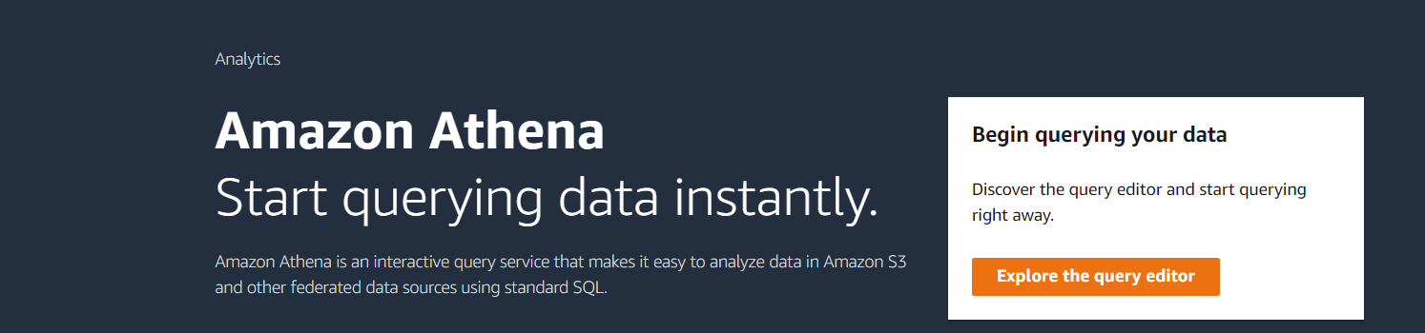
4. In the menu bar, click on **Workgroup:primary.**  
   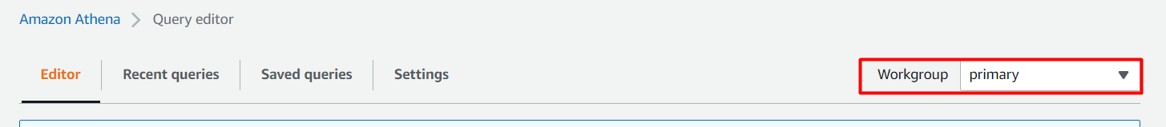
5. To create a workgroup, Click on the **Workgroups**at the left navigation panel. Click on **Create Workgroup**button.  
     
   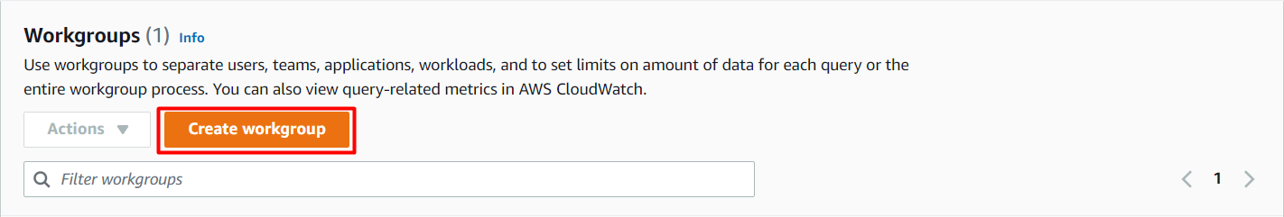
6. Provide details to create a workgroup:
   * Workgroup Name: Enter ***WhizWorkgroup***
   * Description: Enter ***Workgroup for Athena lab***
   * Query result location: **Select the S3 bucket**, whose name is starting with **whizlabs...** by clicking on **Browse**button.  
     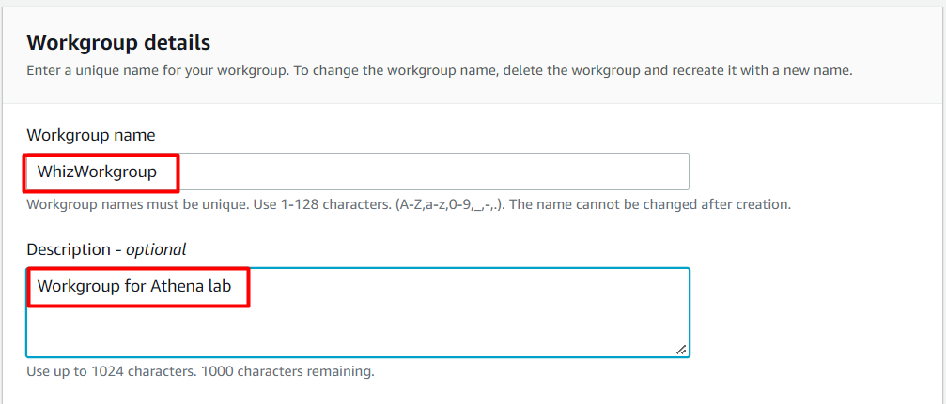
   * Leave other settings as default
   * Click on the **Create Workgroup** button.
7. Now it will list all the Workgroups  
   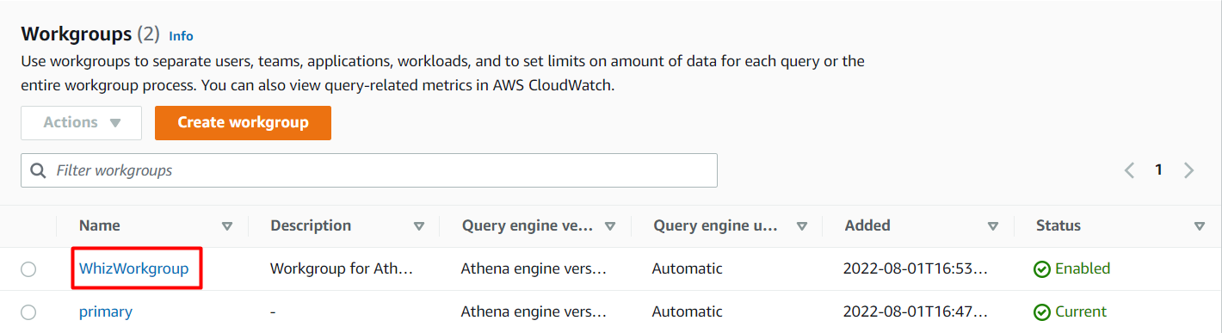
8. Select **WhizWorkgroup** by checking on the option and click on the **Actions** and then click on **Switch workgroup** button.  
   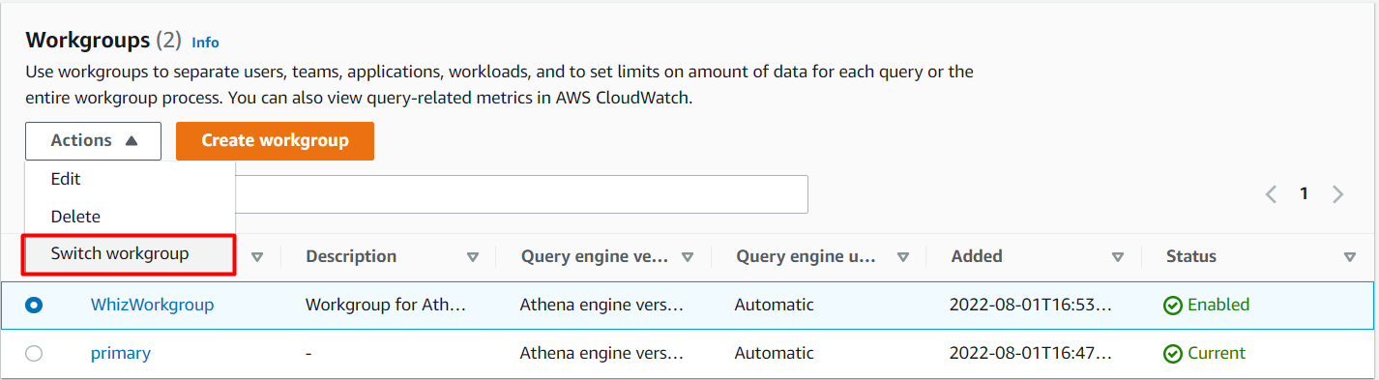

Task 3: Create a database in Glue

1. Make sure you are in the **N.Virginia** Region.
2. Navigate to **Services** menu at the top, then click on **AWS Glue** in the **Analytics** section.
3. By default, you will be able to see the **tables** present. In the left sidebar, Under **Data catalog**, Click on **Databases**.
4. Click on the 
5. In the pop-up menu, enter the database name as ***whizgluedatabase*** and click on the **Create** button.  
   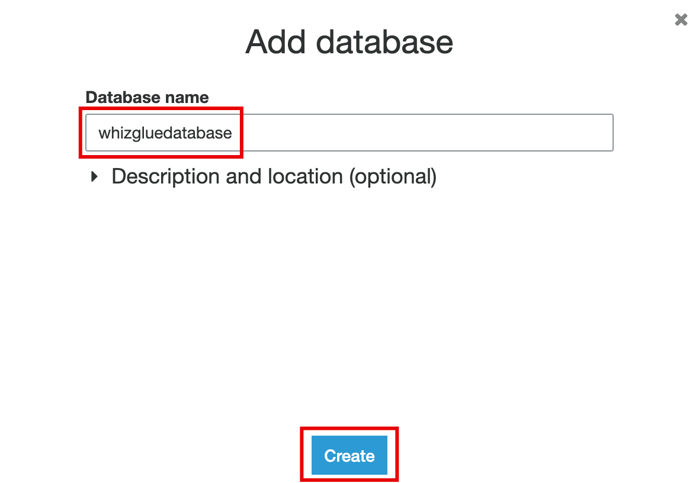
6. The database is now created.  
   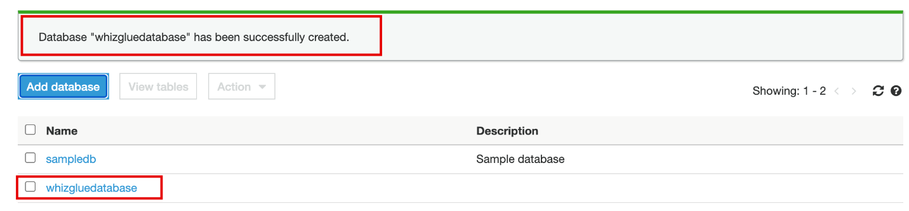

Task 4: Create a table in Glue

1. In the left sidebar, Under **Data catalog**, Click on **Tables**.
2. To create a table, click on the **Add tables** button and select **Add table manually  
   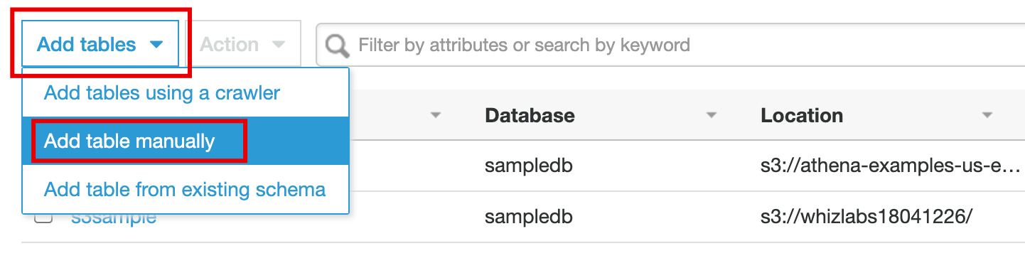**
3. In the **Set up your table's properties**section, do the following:
   * Enter the **Table name** as ***whiz-sample-table***
   * select the **Database**, select **whizgluedatabase**
   * Click on the **Next** button.

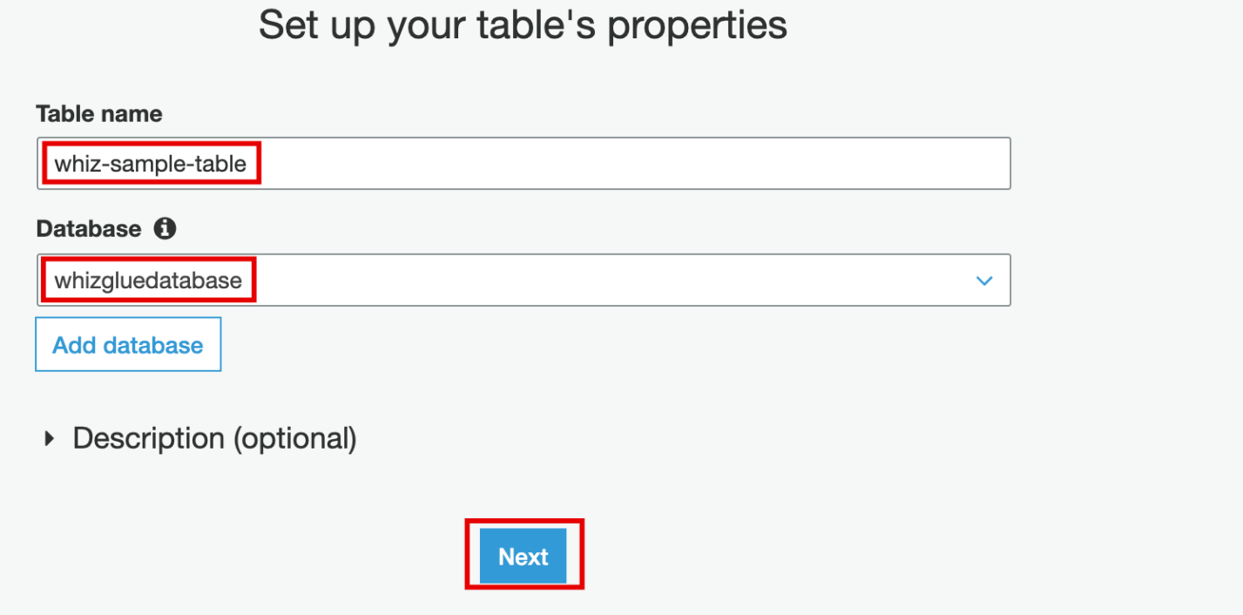

1. In the Add a data store section, do the following:
   * **Select the type of source**: S3 (default)
   * **Data is located in:** Specified path in my account (default)
   * **Include path:** Select the S3 bucket name starting with **whizlabs...**
   * Click on the **Next** button below to proceed further.

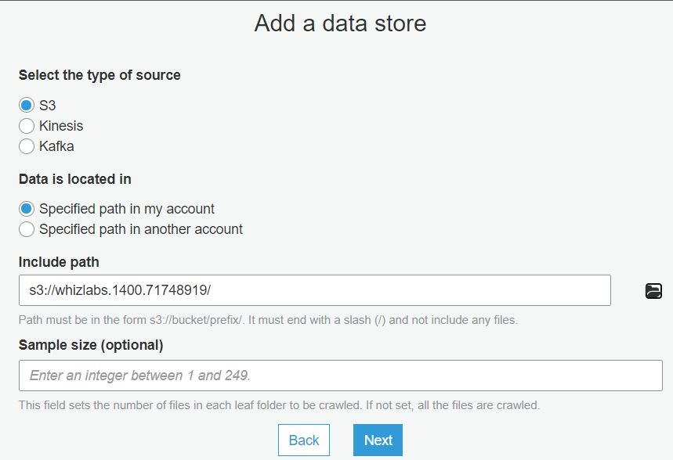

1. In the **Choose a data format** section, do the following:
   * Select **Classification** as **CSV**
   * Choose **delimiter** as **Comma: ,**
   * Click on the **Next** button.  
     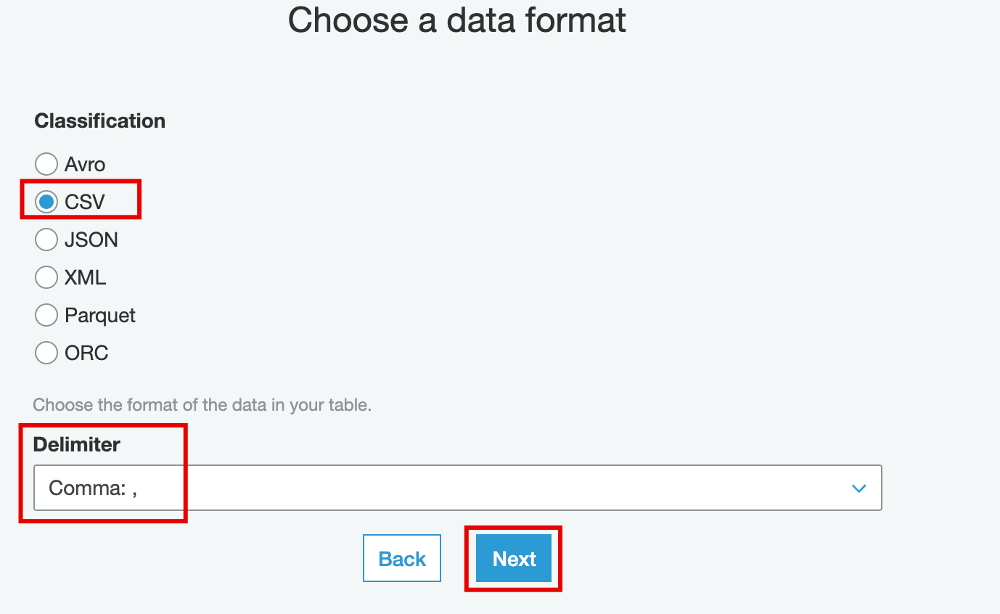
2. In the Define a schema section, we will add 2 columns.
   * Click on the 
   * Column name: Enter ***Expense_Type*** and Column Type: Select **string**
   * Click on the **Add** button below.
   * Click on the  again.
   * Column name: Enter ***Expense_Category***andColumn Type: Select**string**
   * Click on the **Add** button below.
   * After adding both the columns, click on the **Next** button.  
     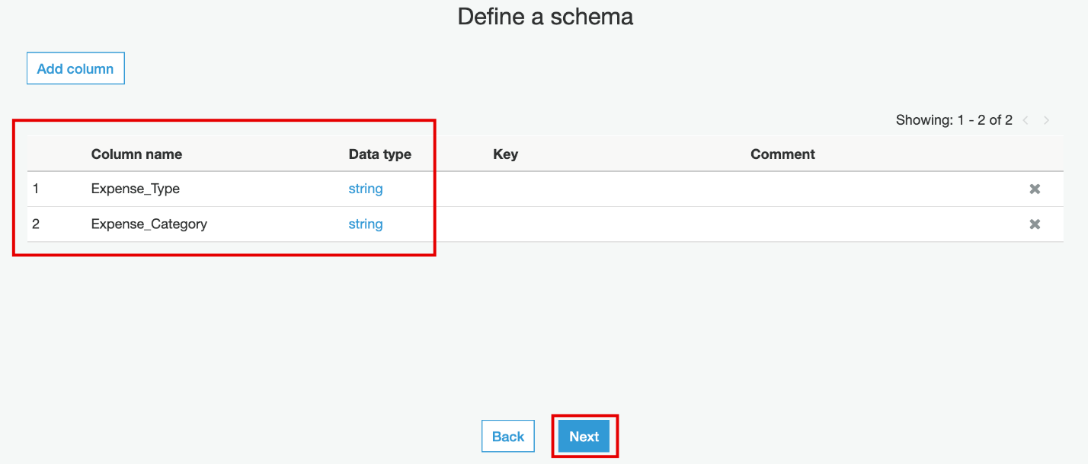
3. Add partition indices: Leave everything as default and click on **Next** button.
4. Review the configuration of the table and click on the **Finish** button.

The table is now created.  
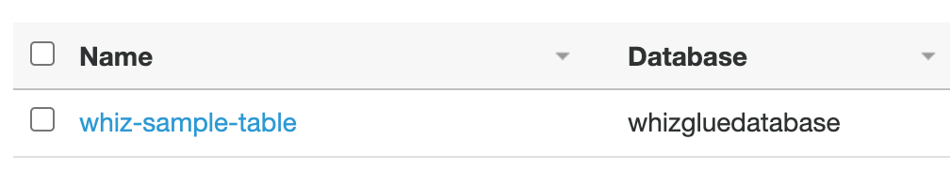

Task 5: Query table in Athena

1. Make sure you are in the **N.Virginia** Region.
2. Navigate to  menu in the top, then click on **Athena** in the **Analytics** section.
3. Click on the **Get started** button, if asked.
4. In the left sidebar, under data source, Select the database as **whizgluedatabase.**
5. Then you will see our table, **whiz-sample-table*.***
6. To preview the data of **whiz-sample-table** table, Click on  and select the **Preview table.**  
      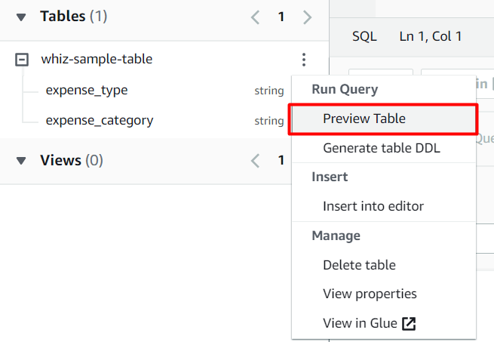
7. Query editor will automatically generate the SQL statement for querying the first 10 columns.
8. The result of the query is shown below.  
   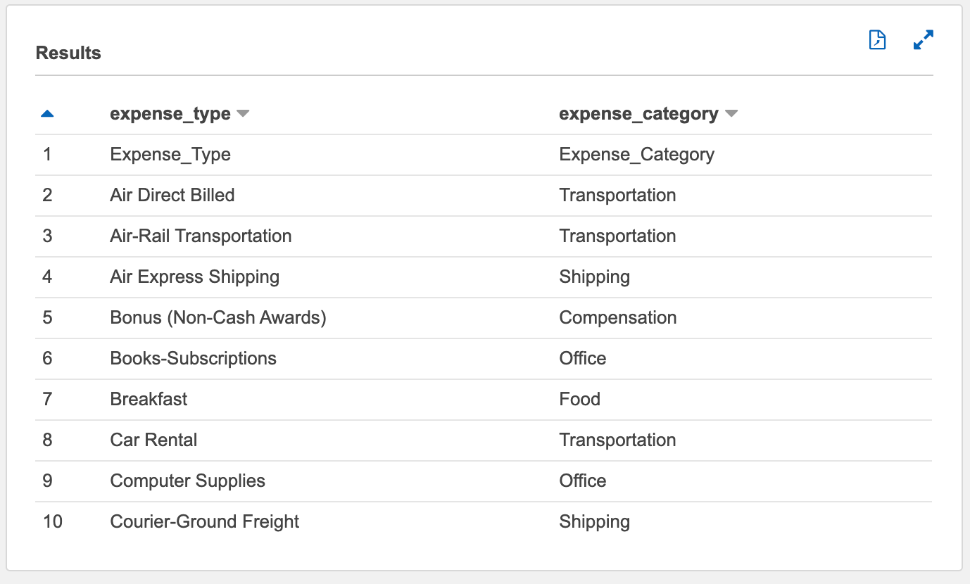
9. To get the results of all expenses types under **expense_category** of food, paste the following SQL statement into the query editor.

* **SELECT * FROM "whizgluedatabase"."whiz-sample-table" where expense_category = 'Food';**

**Note**: To execute the queries through the keyboard directly use the shortcut **Ctrl + Enter (For windows)** or **Tab + Enter (For Mac)**

1. You can play around with some of the queries like:
2. Getting a total number of rows present by running the following SQL statement in the query editor.

* **SELECT count(*) FROM "whizgluedatabase"."whiz-sample-table";**

Task 6: Validation Test

1. Once the lab steps are completed, please click on the  button on the left side panel.
2. This will validate the resources in the AWS account and displays whether you have completed this lab successfully or not.
3. Sample output :

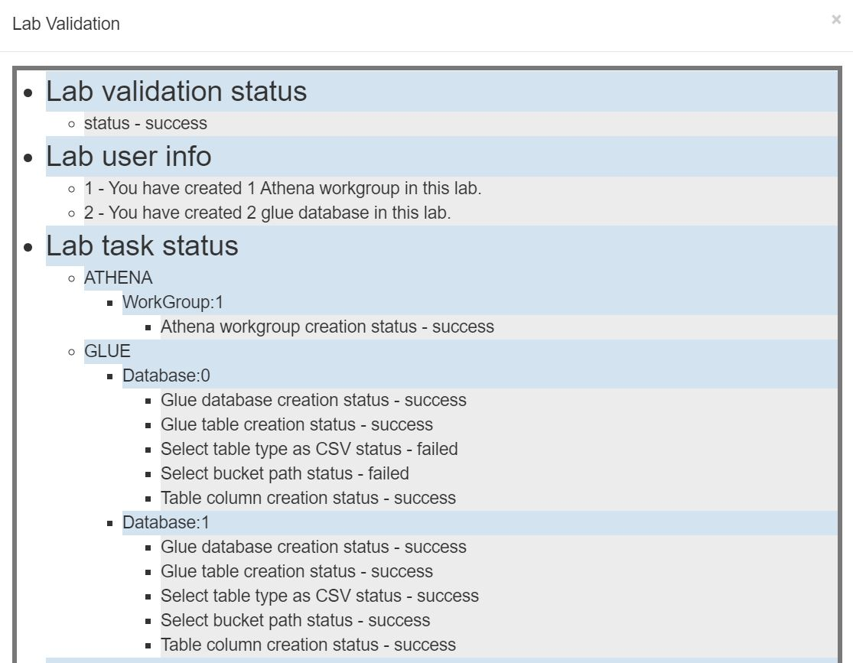

Task 7: Delete AWS Resources

Deleting the database and table in Glue

1. Navigate to  menu at the top, then click on **AWS Glue** in the **Analytics** section.
2. By default, you will be able to see the **tables** present. In the left sidebar, Under **Data catalog**, Click on **Databases**.
3. Databases will be present here, our database is **whizgluedatabase**.  
     
   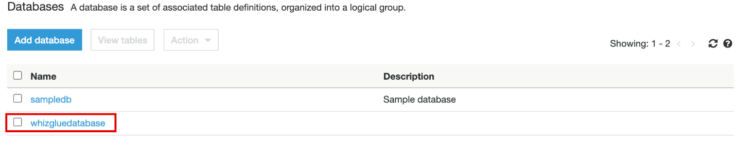
4. To delete the database, perform the following tasks:
   * Select the database, **whizgluedatabase**
   * Click on **Actions**.
   * Choose **Delete database** from the menu.  
       
     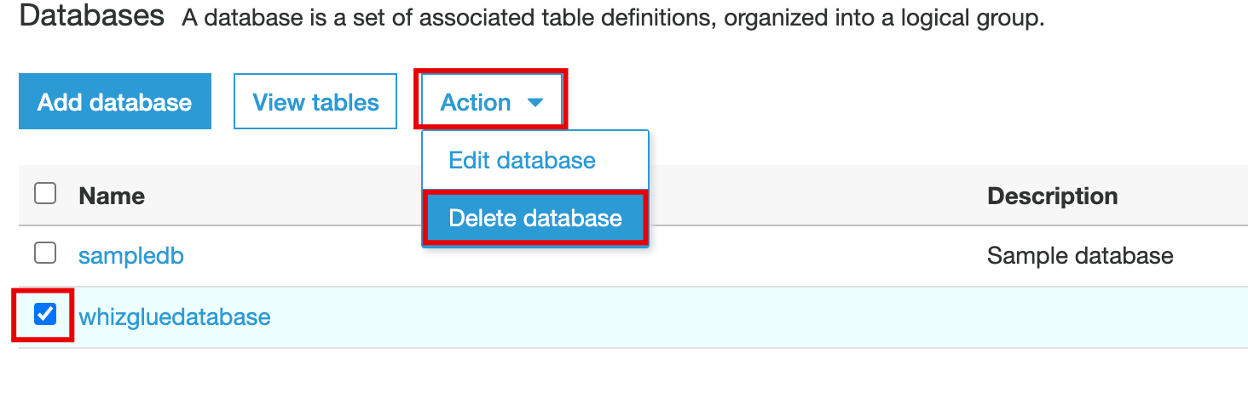
5. Confirm the deletion on the pop-up by clicking on the **Delete** button  
   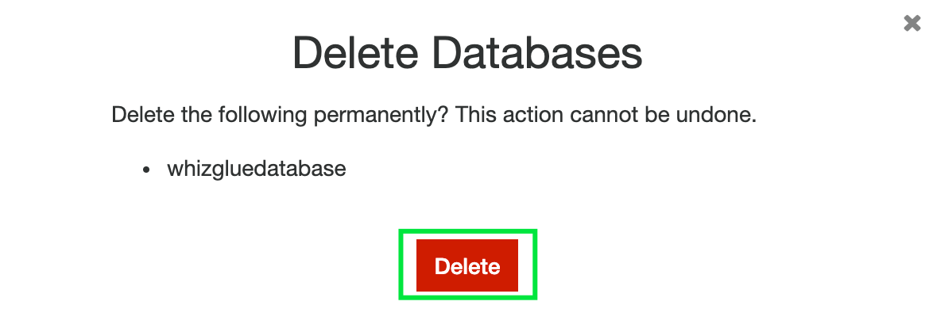
6. The database is successfully deleted now.  
   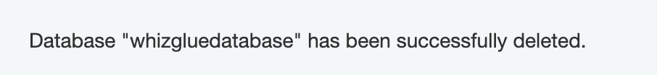

Deleting workgroup

1. Navigate to  menu in the top, then click on **Athena** in the  section.
2. Click on the workgroup  
   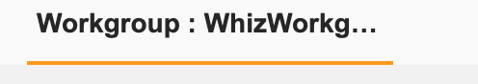
3. Select **WhizWorkgroup** and Click on **View details**
4. Click on **Delete workgroup**
5. Confirm the deletion on the pop-up by clicking on the **Delete** button

**Completion and Conclusion**

1. You have successfully created and configured a workgroup in Amazon Athena.
2. You have successfully created a table in Amazon Athena with S3
3. You have successfully queried the SQL statements in the Query editor of Athena.
4. You have successfully created a webpage and published it.

**End Lab**

1. Sign out of AWS Account.
2. You have successfully completed the lab.
3. Once you have completed the steps, click on  from your whizlabs dashboard.